Multivariate Linear Regression
Consider that instead of having just a single feature, we have multiple features. Thus, the value $x^{\left(i\right)}$ would no longer be a single value but rather a vector, $x^{\left(i\right)}=\left[\begin{matrix}x_{1}^{\left(i\right)} \\ x_{2}^{\left(i\right)} \\ … \\ x_{n}^{\left(i\right)}\end{matrix}\right]$.
If we consider all the data points, we can store them in transposed form, like this:
$$x^{T}=\left[\begin{matrix}x_{1}^{\left(1\right)} & x_{2}^{\left(1\right)} & … & x_{n}^{\left(1\right)} \\ x_{1}^{\left(2\right)} & x_{2}^{\left(2\right)} & … & x_{n}^{\left(2\right)} \\ … & … & … & … \\ x_{1}^{\left(m\right)} & x_{2}^{\left(m\right)} & … & x_{n}^{\left(m\right)}\end{matrix}\right]$$
This is called a data matrix.

For the $n$ features in a particular data point, we will also have $n$ coefficients. Thus, the hypothesis will become like this:
$$h_{θ}\left(x\right)=θ_{0}+θ_{1}x_{1}+θ_{2}x_{2}+…+θ_{n}x_{n}$$
$$=\left[\begin{matrix}x_{0}^{\left(1\right)} & x_{1}^{\left(1\right)} & … & x_{n}^{\left(1\right)} \\ x_{0}^{\left(2\right)} & x_{1}^{\left(2\right)} & … & x_{n}^{\left(2\right)} \\ … & … & … & … \\ x_{0}^{\left(m\right)} & x_{1}^{\left(m\right)} & … & x_{n}^{\left(m\right)}\end{matrix}\right]\left[\begin{matrix}θ_{0} \\ θ_{1} \\ … \\ θ_{n}\end{matrix}\right]$$
$$=x^{T}θ$$

Both the cost function and the gradient descent algorithm will remain exactly the same.
$$θ_{j}≔θ_{j}-\frac{1}{m}\sum_{i=1}^{m}{\left(h_{θ}\left(x^{\left(i\right)}\right)-y^{\left(i\right)}\right)⋅x_{j}^{\left(i\right)}}$$

Feature Scaling
Feature Scaling is a pre-processing technique that can be used to improve the performance of the gradient descent algorithm when using it with multiple features.
Suppose $x_{1}$ is the area of a house and $x_{2}$ is the number of rooms. The number of rooms can vary from $1-5$ while the area can vary from $500-4000$. Thus, the ranges of the two features are wildly different. In a scenario like this, we will have a narrow contour plot. A change in $x_{1}$ will cause a significant change in the cost function. The parameter for $x_{1}$, $θ_{1}$, will pull the gradient descent algorithm away from the minima, thus slowing down the process.
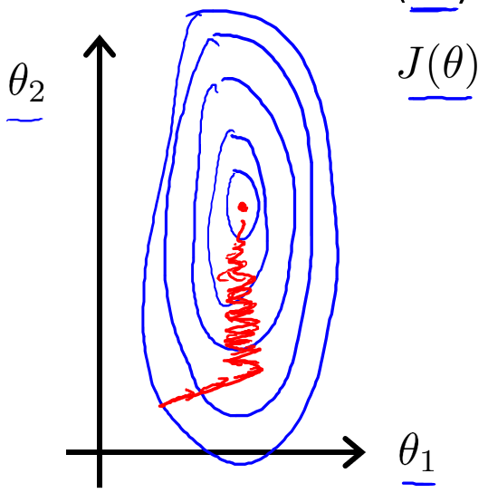

To solve this issue, we can use the following formula on all values of $x$.
$$x≔\frac{x-x_{min}}{x_{max}-x_{min}}-0.5$$
For example, if the values of $x$ are from $5$ to $10$, this changes the range to $-0.5$ to $+0.5$. If this is inconvenient, it can be doubled to $-1$ to $1$.

Mean Normalization
Another optimization technique is called mean normalization.
$$x≔\frac{x-μ}{s}$$
Here, $μ$ is the average of all the values of $x$ and $s$ is either the range or the standard deviation. We can also use the variance instead of $s$.

